CLEARGUARD™ INSTRUCTIONS
- LAY OUT THE TWO LEGS AND BARRIER
- INSERT EACH LEG INTO THE SLITS ON THE BARRIER
- STAND BARRIER UP
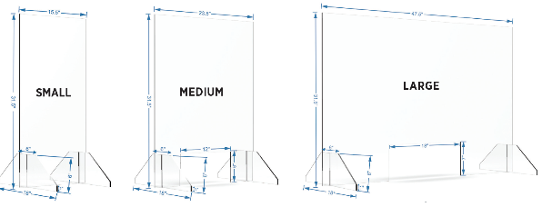
Please contact Kim with questions, missing pieces or in event of receiving an item *damaged in transit. *In event of damage please retain packaging & please take pictures
CALL: (513)761-7614 (513) 403-1154
EMAIL: kkeighley@lumawaresafety.com

CLEARGUARD™ INSTRUCTIONS
- LAY OUT THE TWO LEGS AND BARRIER
- INSERT EACH LEG INTO THE SLITS ON THE BARRIER
- STAND BARRIER UP
Please contact Kim with questions, missing pieces or in event of receiving an item *damaged in transit. *In event of damage please retain packaging & please take pictures
CALL: (513)761-7614 (513) 403-1154
EMAIL: kkeighley@lumawaresafety.com

